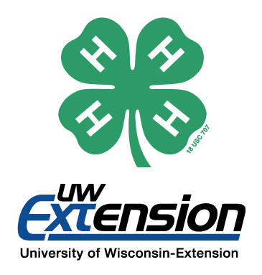
2017-2018 RACINE COUNTY 4-H VOLUNTEER AWARDS

Please fill out and return your nomination form by
Friday, September 28, 2018 at 4:30 p.m.
It may be dropped off in person at the Burlington office (209 North Main Street, Burlington) on weekdays between 8:00 a.m.-12:00 p.m. or 12:30-4:30 p.m. by the stated date and time, placed in the drop box on the south side of the Burlington office by the stated date and time, postmarked via USPS mail by the stated date, emailed (pam.debele@racinecounty.com)/faxed (262-767-2949) timestamped by the stated date and time, or completed via Google form at https://goo.gl/forms/1y7KKAKvErNcYzqA3 by the stated date and time. If you submit via Google form, you do NOT need to submit a paper copy.
Late forms are unable to be accepted.

Person Submitting Nomination:
Email:
Name of nominee (one nominee per submission):

I am nominating this person for: (Check all that apply)
4-H Volunteer of the Year
This volunteer award recognizes a 4-H volunteer who has had a positive impact on 4-H and 4-H youth on the club and county level for less than 10 years and who demonstrates exemplary service to 4-H while promoting service through volunteerism as both an opportunity and a privilege.
4-H Lifetime Volunteer of the Year
This volunteer award recognizes a 4-H volunteer who has had a positive impact on 4-H and 4-H youth on the club and county level for more than 10 years and who demonstrates exemplary service to 4-H while promoting service through volunteerism as both an opportunity and a privilege.
Friend of 4-H
The Friend of 4-H Award recognizes a volunteer, group, or organization who demonstrates exemplary service to and support of 4-H at the county level. Contributions or assistance provided by the nominee could be of an educational, financial, advisory, legislative, or other supportive nature.
4-H Community Servant Award
The Community Servant Award recognizes a 4-H member or 4-H group who demonstrates exemplary service to 4-H and their community through an ongoing commitment to community service and to making a positive impact on the community.
4-H Alumni Award
The 4-H Alumni Award is given to a past 4-H member who demonstrates active citizenship, leadership, and 4-H involvement.

In the space provided, give a brief description of the nominee’s qualifications for this award. Please reference the requirements for this award and include any other information that would be of interest to the selection committee.

