Racine County 4H “Friday Night Lights” Open Speed Show
Come out and support the Racine County Horse and Pony Project for a fun filled night!
June 15th - Racine County Fairgrounds - Start time 6pm, Gates open at 4pm
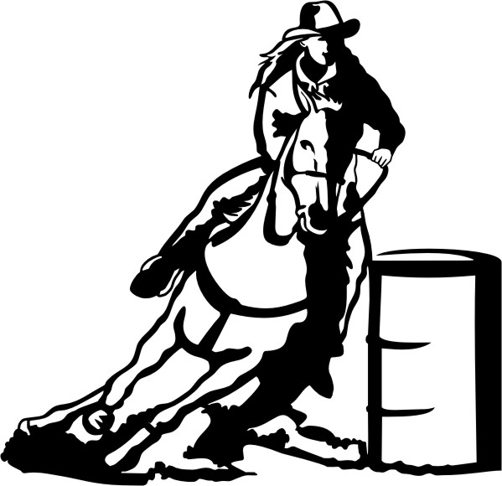
Class List
- Open Poles
- Jr Poles*
- Sr Poles*
- Open Barrels
- Jr Barrels*
- Sr Barrels*
- Jr Flag*
- Sr Flag*
- Jr LT Special*
- Sr LT Special*
- Jr Plug*
- Sr Plug*

* = 4H class

- MUST pay cash!
- $5 office fee per horse and rider combo
- $3 per 4H/starred class
- $15 per Open class, 100% payback through 3rd place

Age Divisions (as of January 1st)
→ Jr: 13 and under
→ Sr: 14-19 (last year in 4H)
→ Open: All ages
Helmets required for ALL RIDERS when mounted
No alcohol or dogs allowed on grounds
Copy of coggins required
Food stand on grounds

